**1 grep command:**

The grep command searches for a particular pattern of characters, and displays all the lines that contain that pattern.

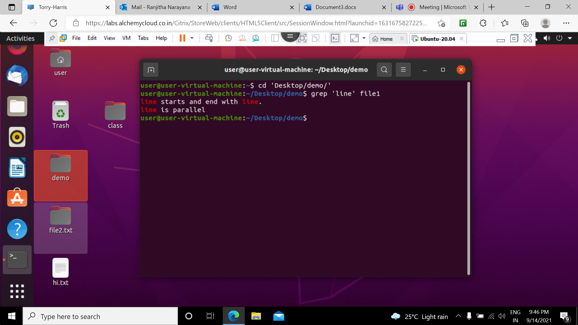

**2 grep -i command:**

This command ignores the case for matching.

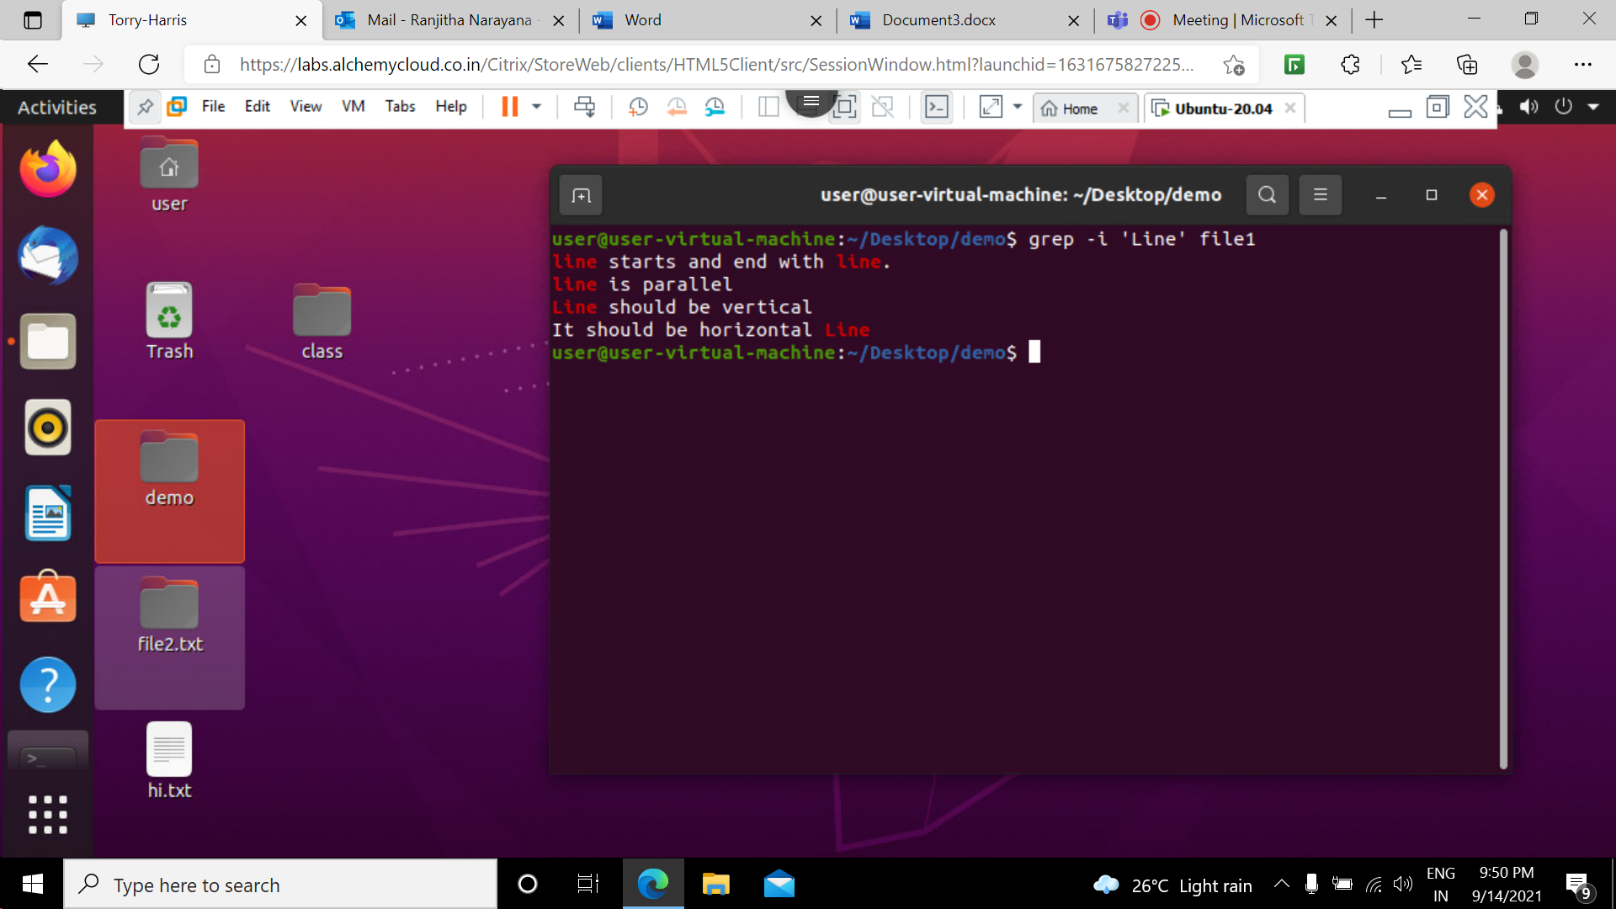

3 **grep -c command:**

This prints only a count of the lines that match a pattern.

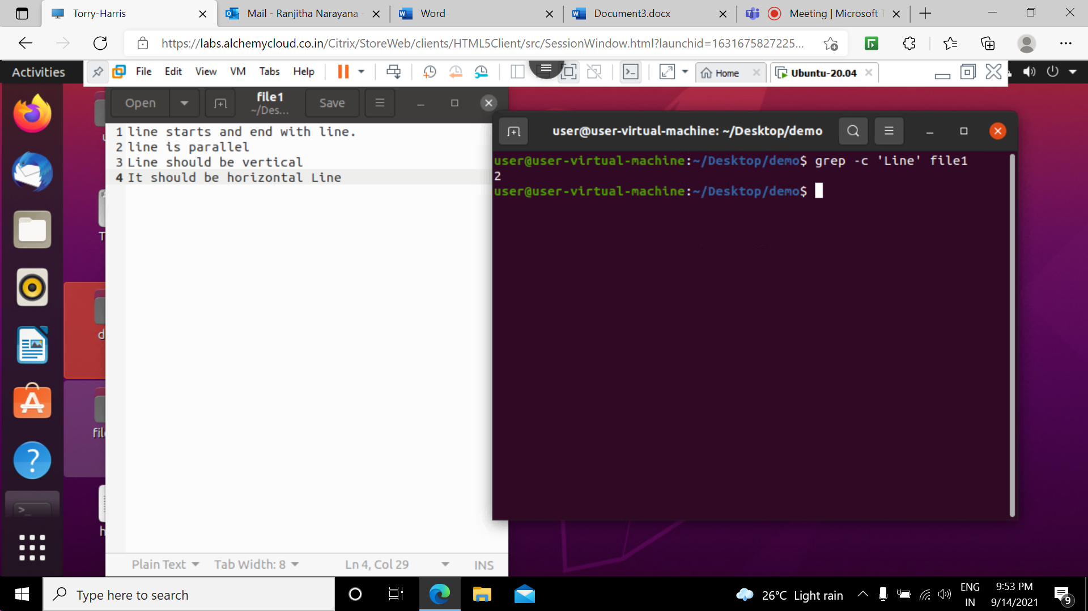

**4 grep -i -c command:**

This prints only a count of lines that match a pattern and it ignores the case for matching .

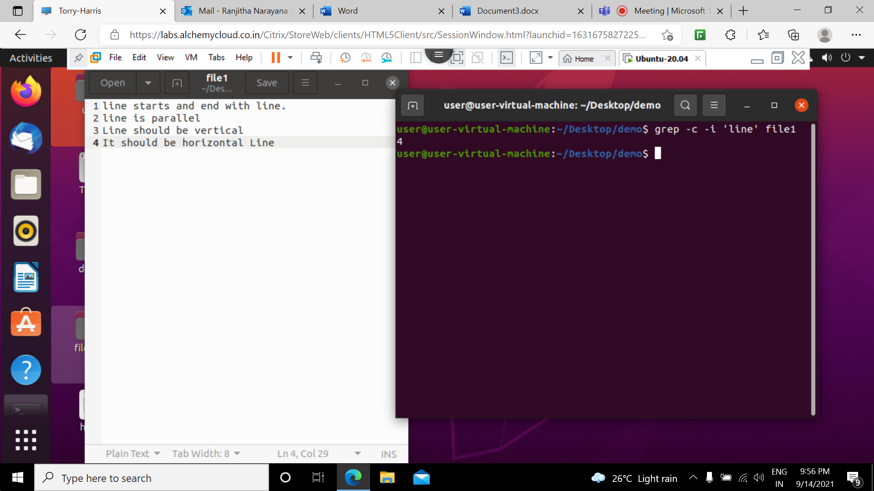

5 **grep -l “ word” * command:**

Display the file names that matches the pattern we can just display the files that contains the given pattern.

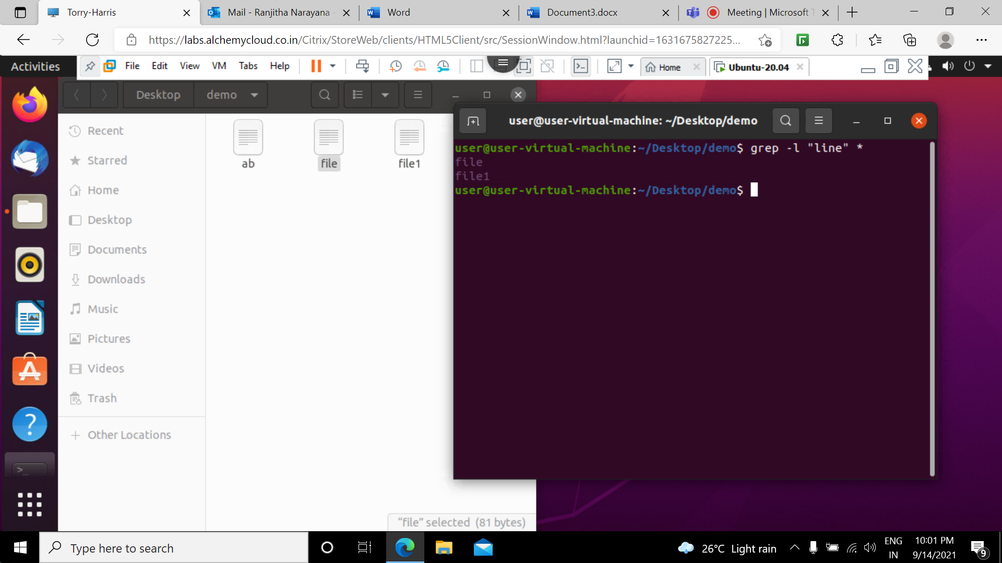

6 **grep -w ‘word’ filename:** This command checks for the whole words in a file it finds the pattern even it is found in a substring.

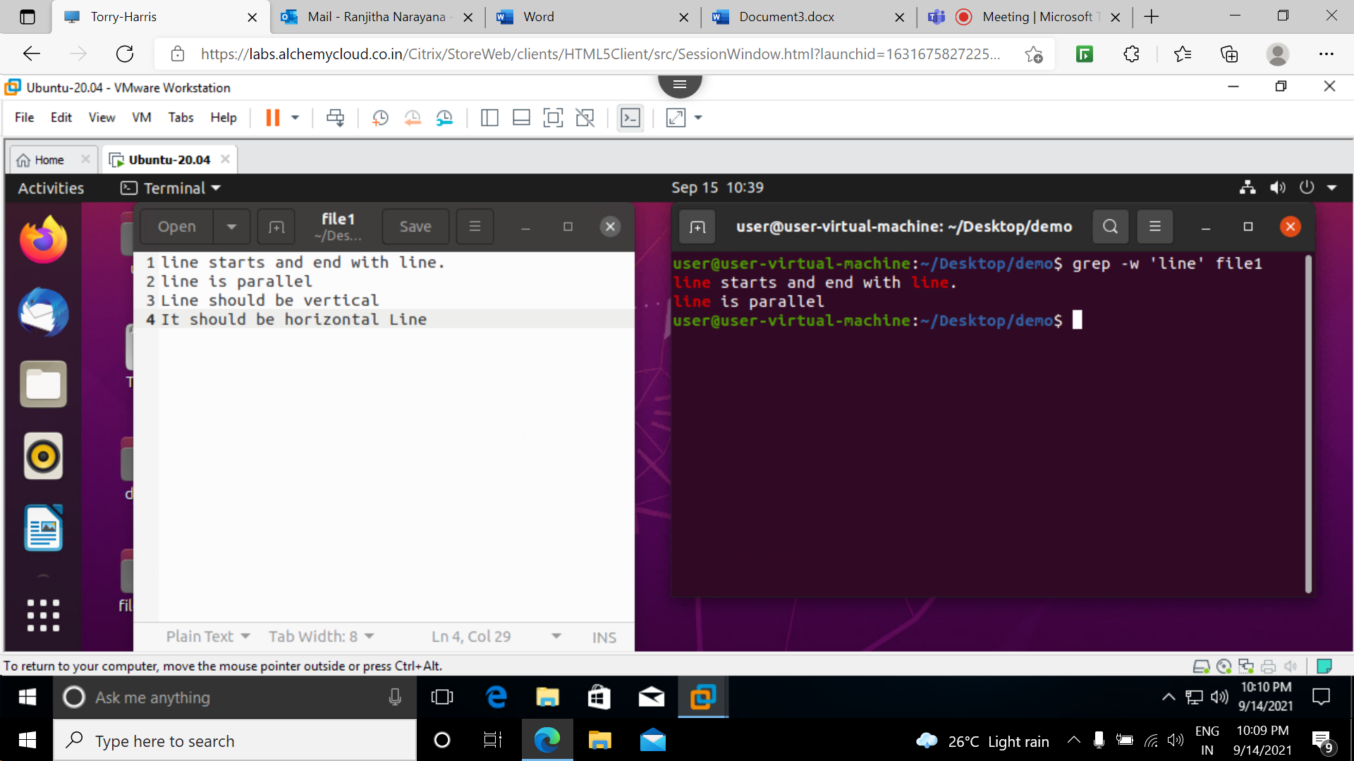

**7 grep -w -i ‘word’ filename:** This command checks for the whole words in a file it finds the pattern even it is found in a substring. But it ignores the case for matching.

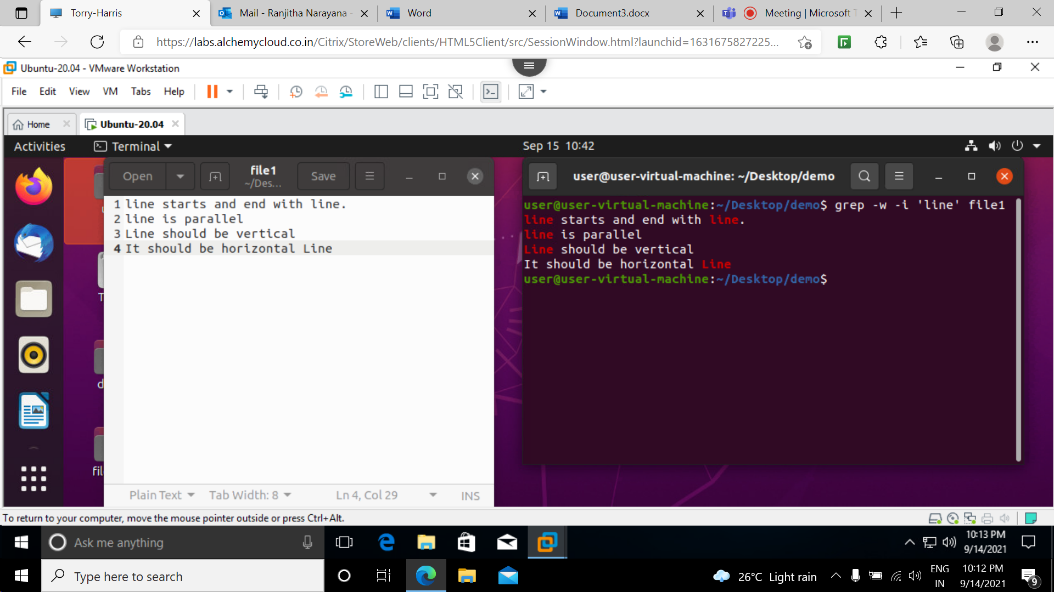

8  **grep -o ‘word’ filename:** this command is used display only the matched string .

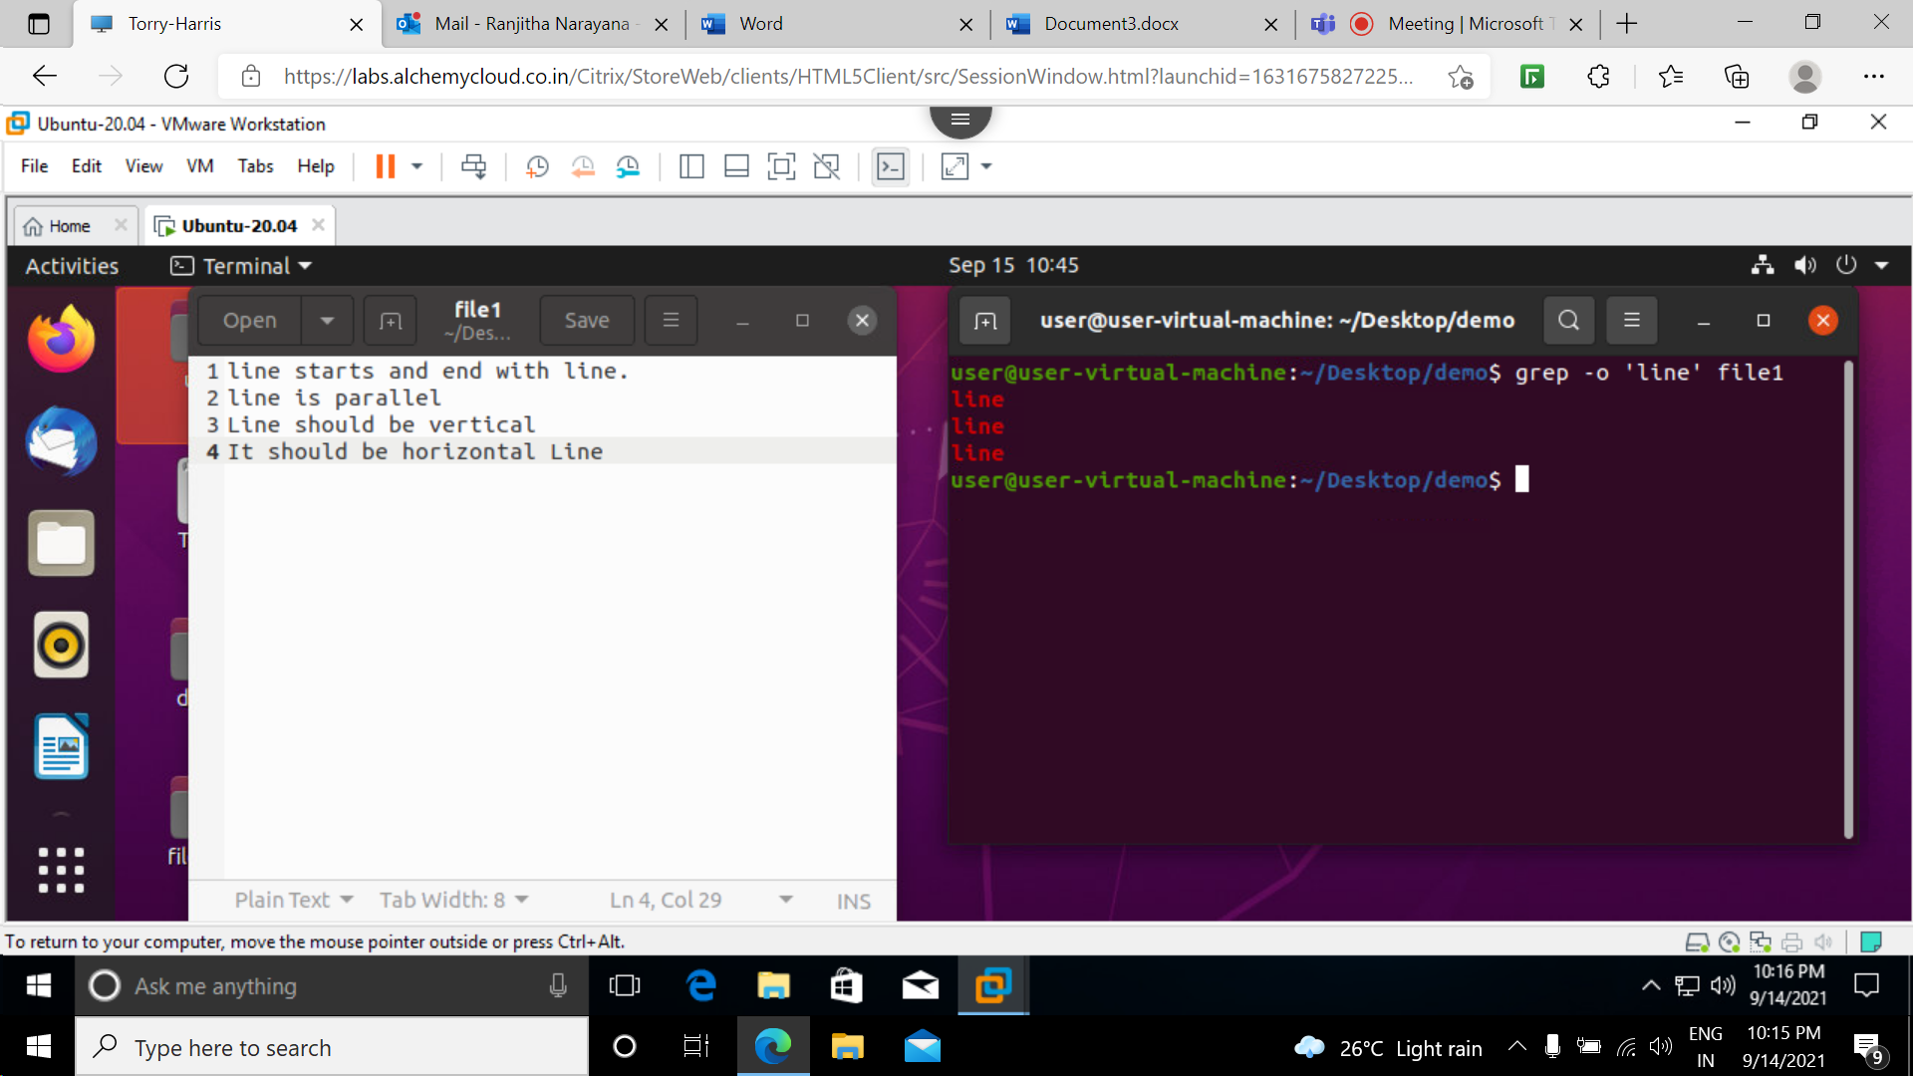

9 **grep -oi ‘word’ filename:** this command is used display only the matched string but it ignores the case for matching .

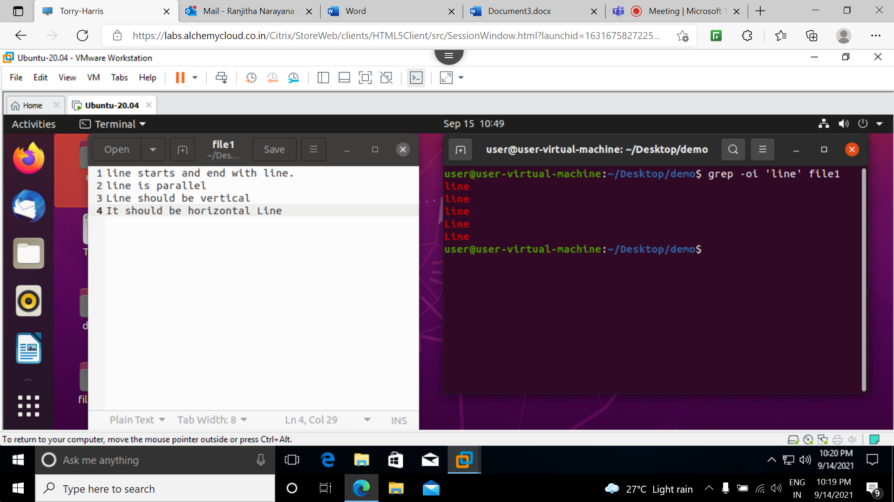

**10 grep -iw ‘word’ filename:** this command ignores the case for matching also checks for the whole words in a file it finds the pattern even it is found in a substring.

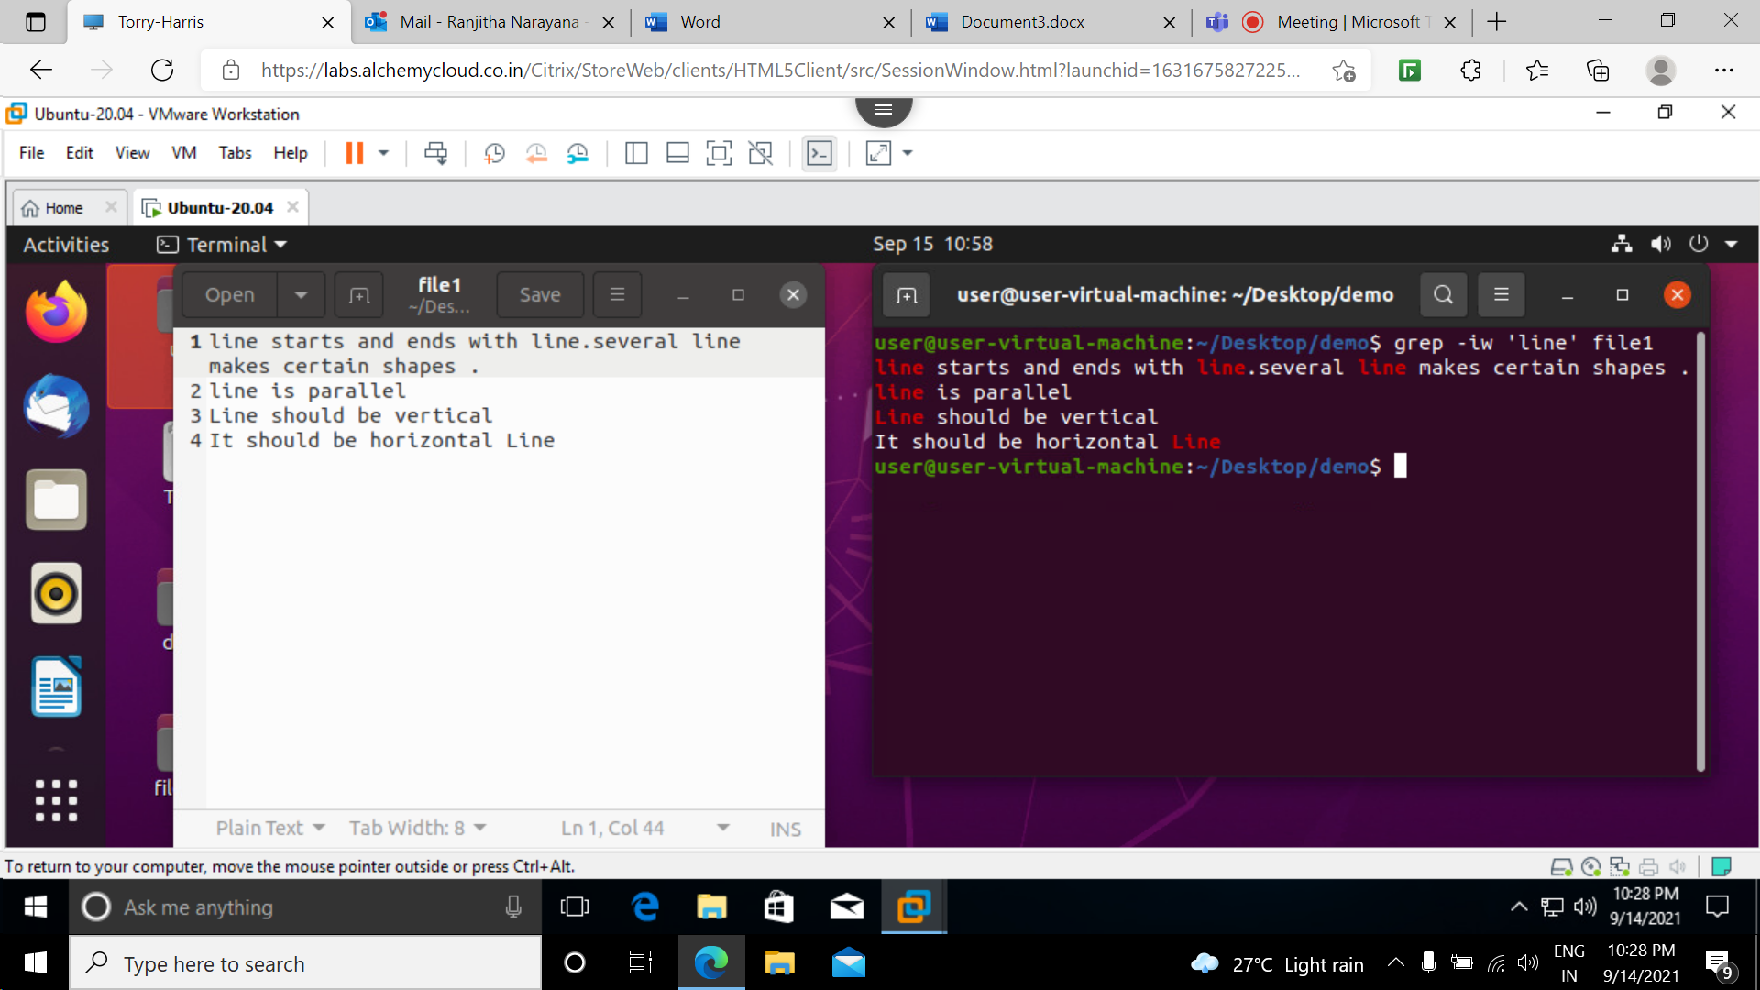

**11 grep -v ‘word’ filename:** used to display the lines that are not matched with the specified search string.

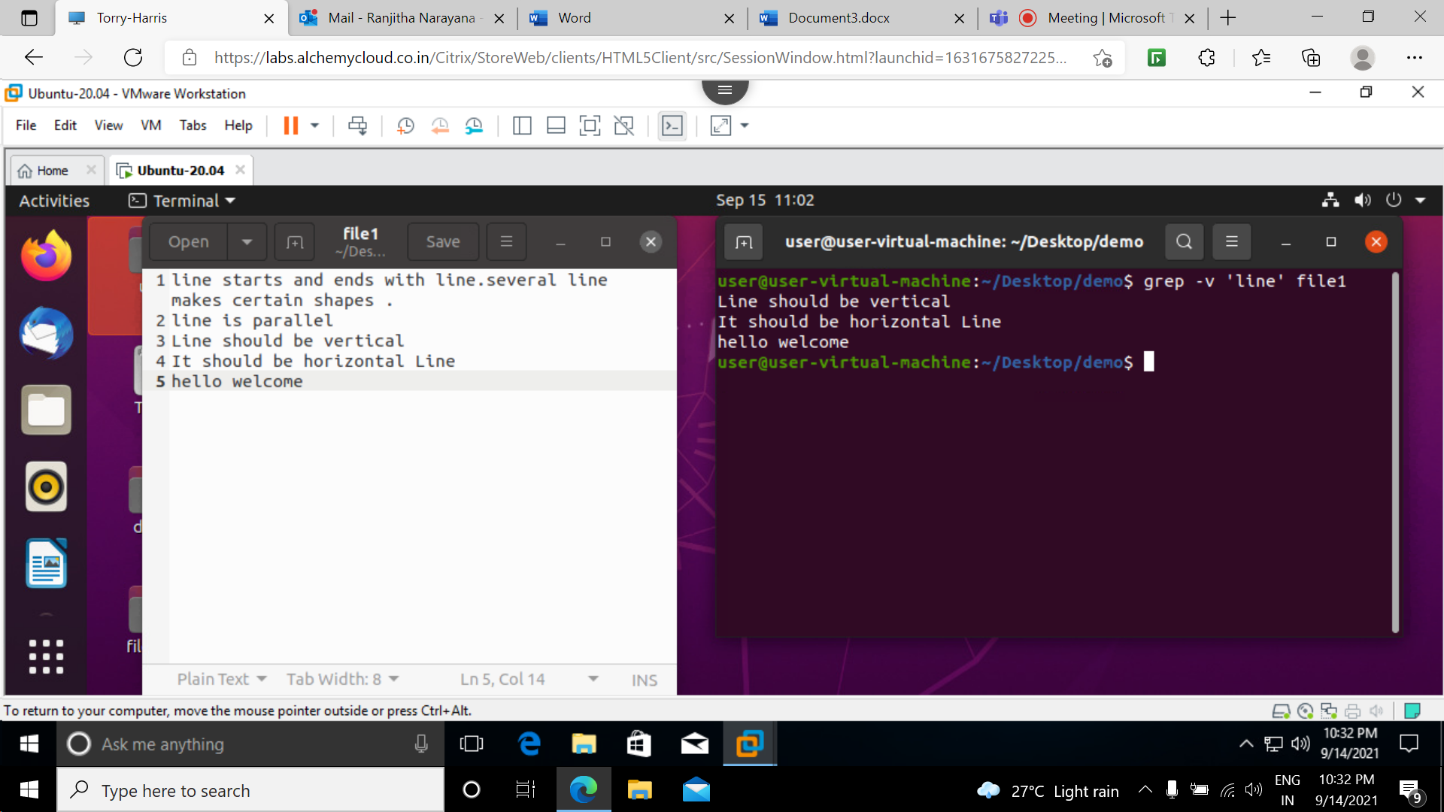

**12 grep -vi ‘word’ filename:** it ignores the case for matching and used to display the lines that are not matched with the specified search string.

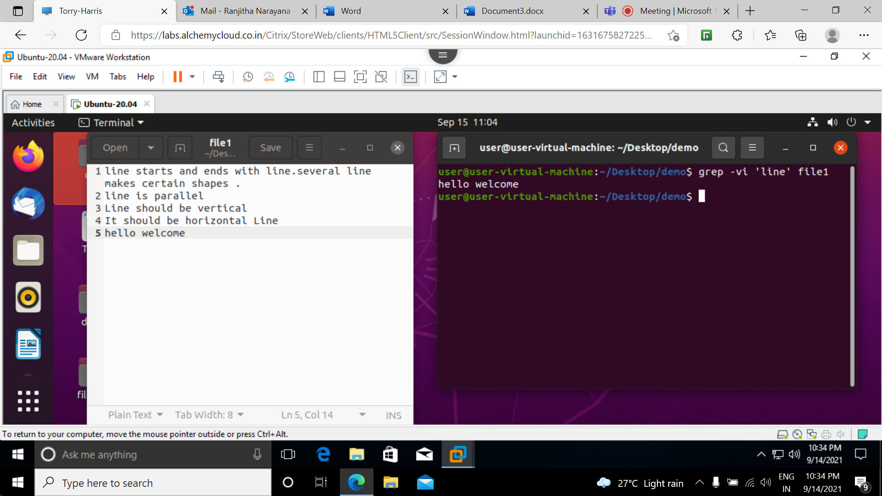

**13 grep -n ‘word’ filename :**  used to show the line number of file with the line matched

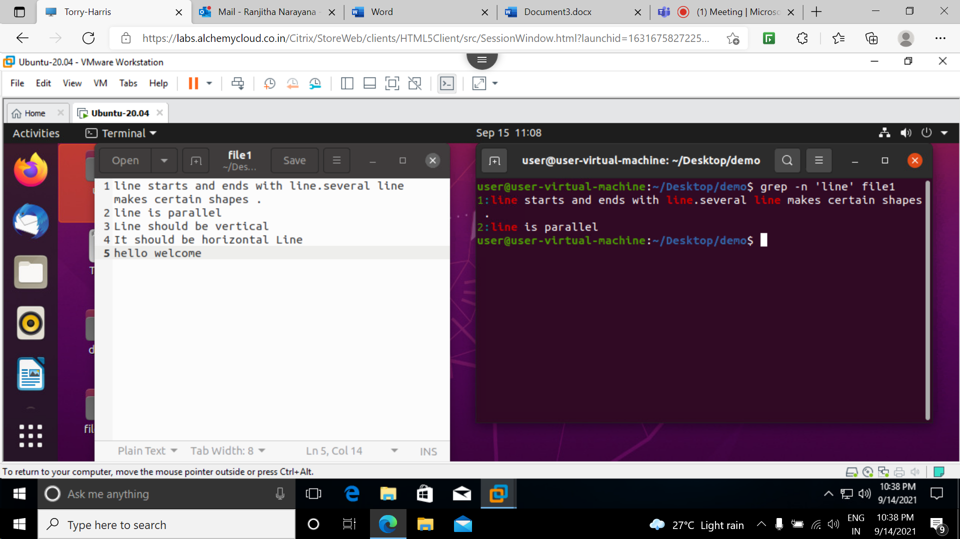

**14 grep “^word” filename:**

This command is used to match the lines that start with a string .

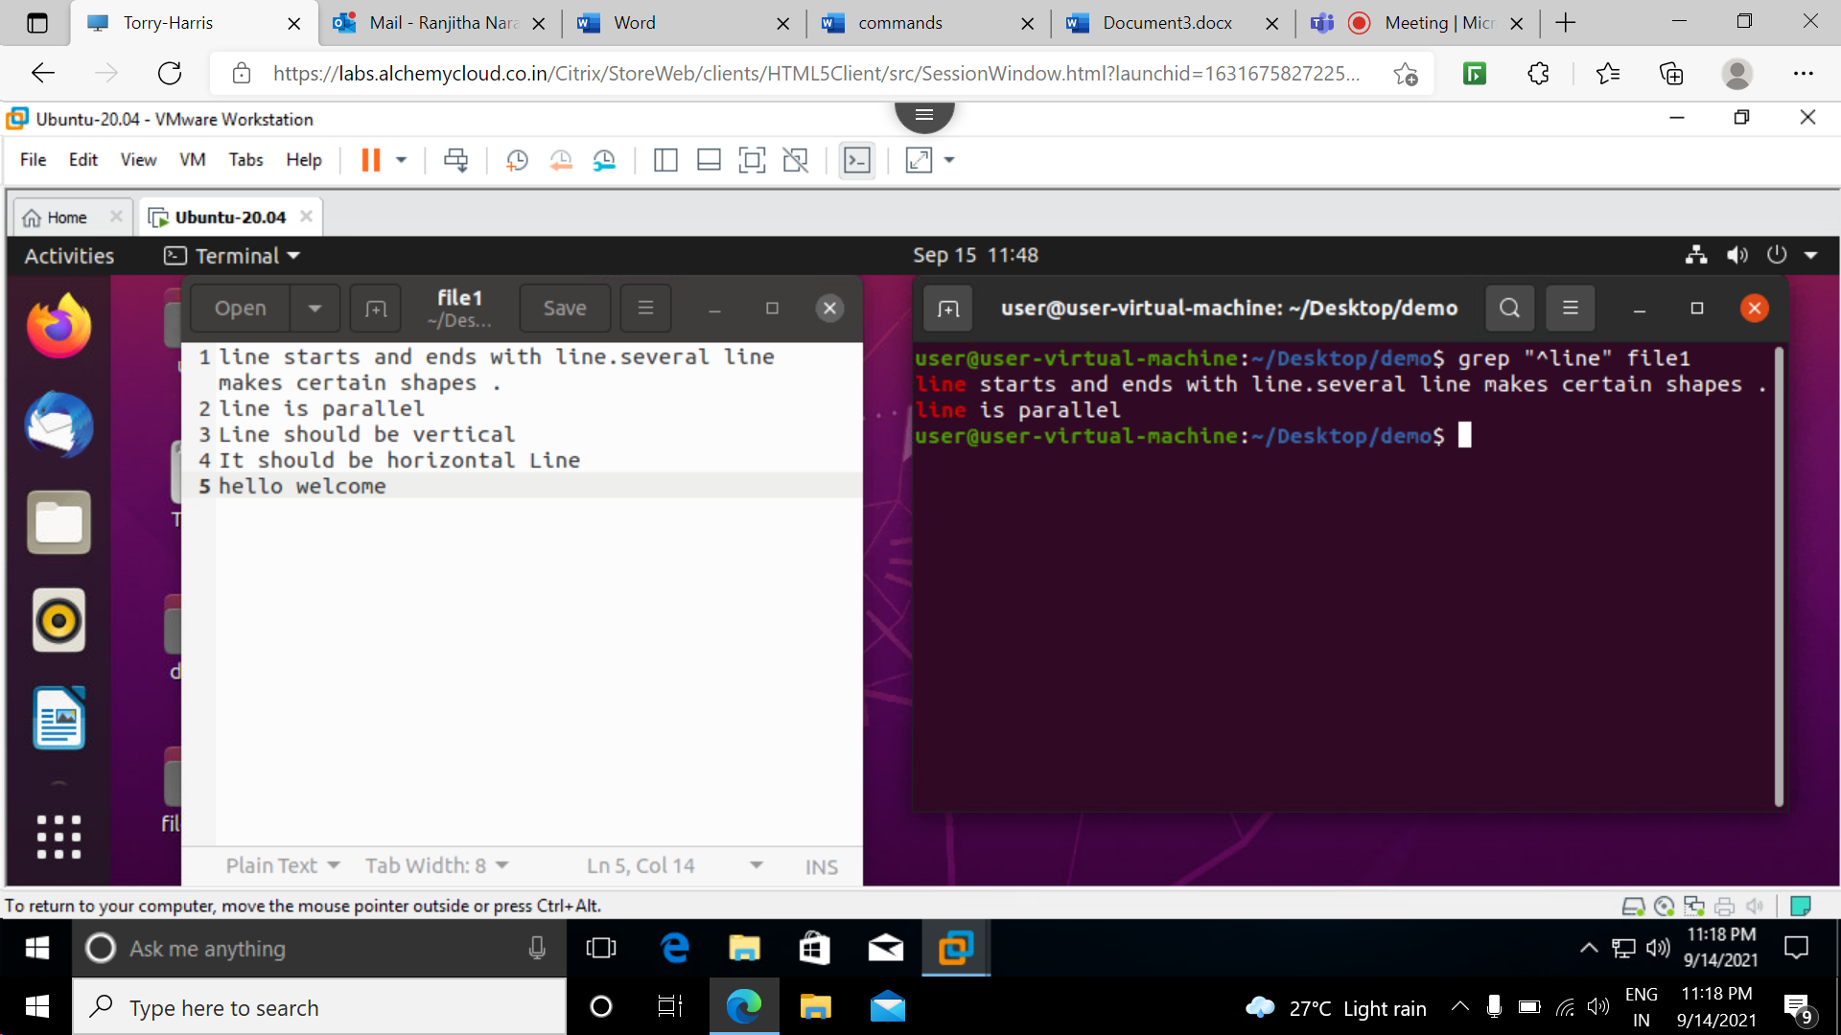

**15 grep “word$” filename:**

This command is used to match the lines which ends with the given string or pattern.

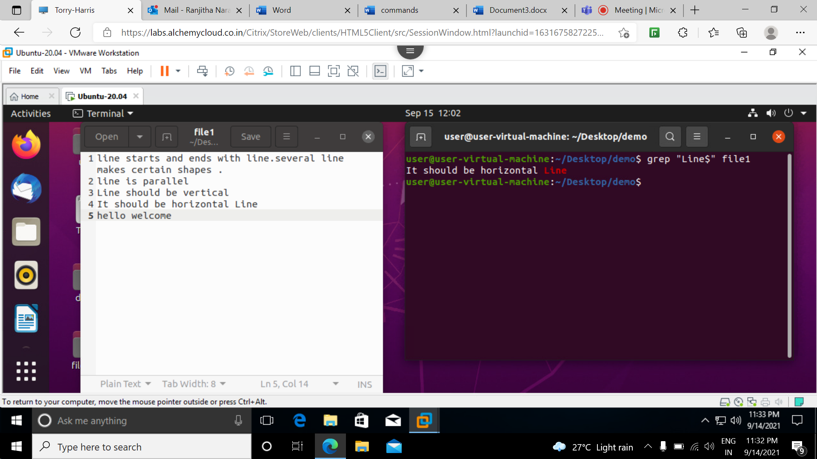

**16 grep -i “^word” filename:**

it ignores the case for matching and used to match the lines that start with a string .

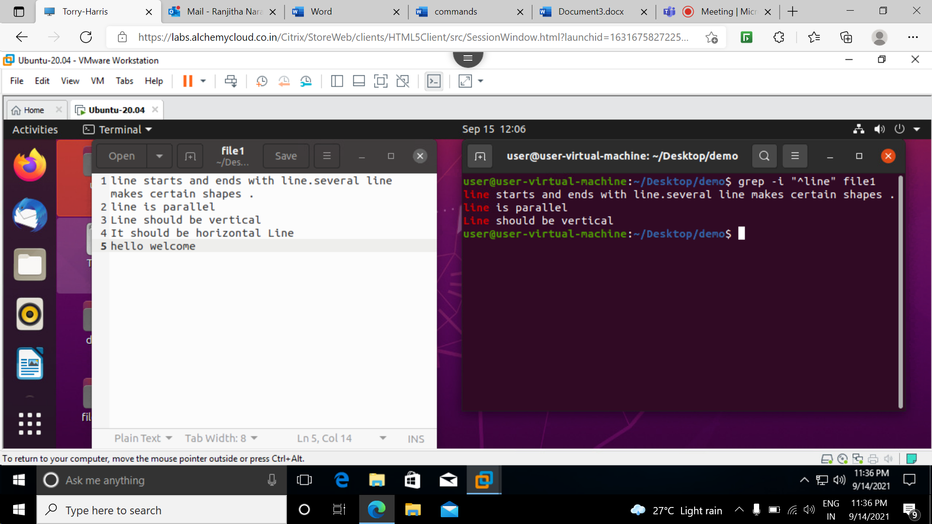

**17 grep -ni “^word .* word$” filename:**

This command is used to display the line that starts and ends with the same string or word.

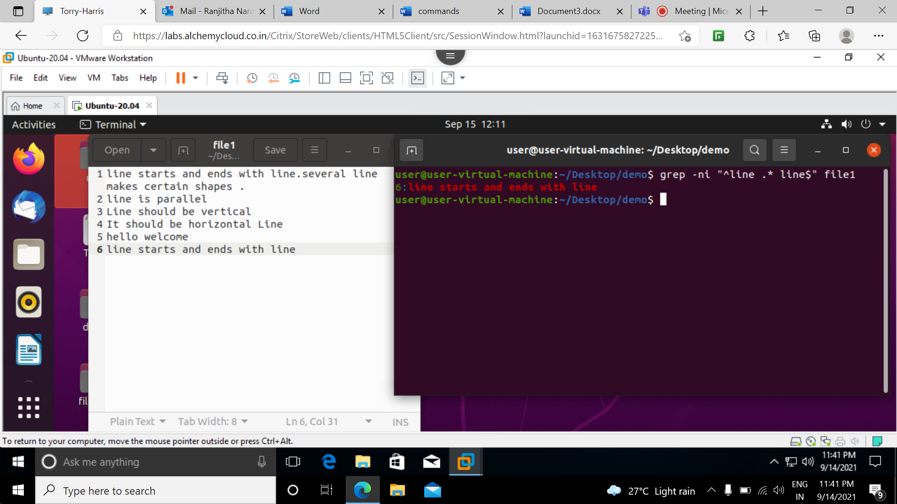

**18 grep -ni -E “^h. *o$” filename:**

This command is used to print the word that starts with the character h followed by any number of characters and ending with character o

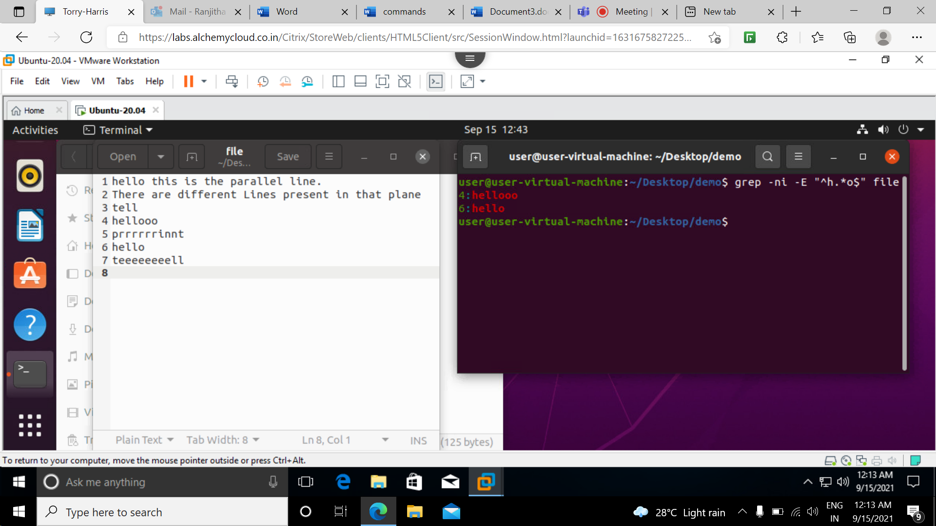

**19 grep -ni -E “^h.l$” filename:**

This command is used to print the word that starts with character h followed by one character in the middle and ends with the character l

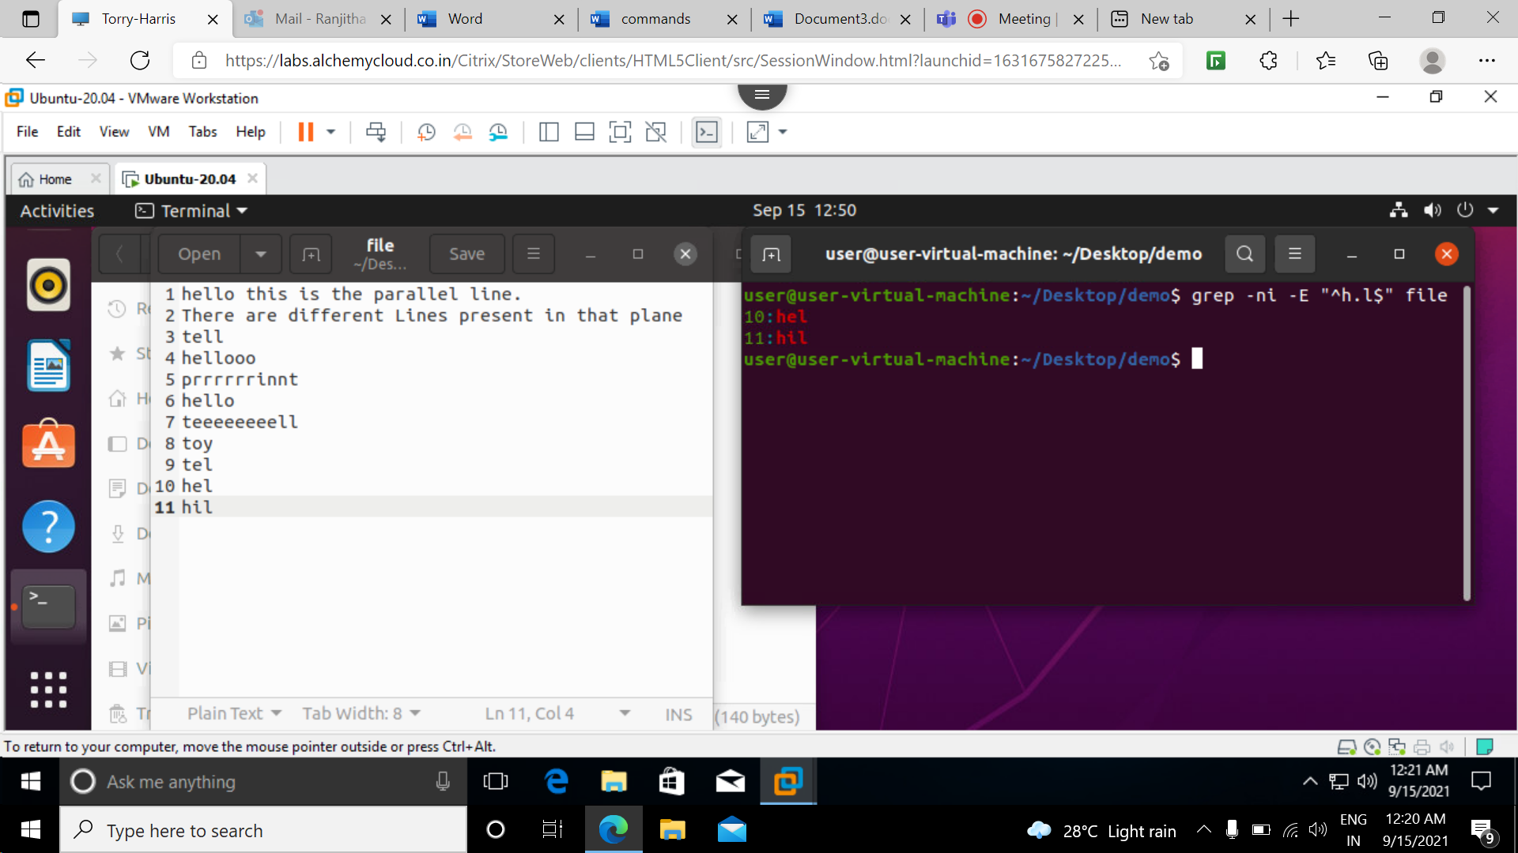

**20 grep -ni -E “h.[I]*l$” filename:**

This command is used print the word that starts with character h and any number of characters and matches zero or any number of preceding character and ends with l character